WBC Segmentation on the Naturalize Dataset through an Image Processing Pipeline
Mahmoud Yasser Mokhtar Sallam
School of Computer Science
University of Nottingham Malaysia
efyms24@nottingham.edu.my

Mirza Zahin Khan Tasneem Ahmad
School of Computer Science
University of Nottingham Malaysia
hcymt4@nottingham.edu.my

Zhi Jian Tsen
School of Computer Science
University of Nottingham Malaysia hcyzt4@nottingham.edu.my

Ralph Matthew Tay Rivera
School of Computer Science
University of Nottingham Malaysia hcyrt1@nottingham.edu.my

Abstract— This paper presents a White Blood Cell (WBC) segmentation pipeline that is specifically designed for the Naturalize dataset which encompasses 11 distinct Peripheral Blood Cell (PBC) types across 16 thousand unique and artificially generated images using the Segment Anything Model. The proposed pipeline converts input images to the LAB colour space, applies bilateral filtering for edge-preserving noise reduction, performs K-means clustering at K=3, and then finally employs contour filtering to isolate cell regions onto a white background. Evaluation using the black-box SDK yielded sub-par results albeit for the Micro Precision reaching in the 90s. Discrepancies related to the dataset were revealed, highlighted and resolved.
Keywords— Naturalize, Image Processing, Blood Cell Classification, Peripheral Blood Cell (PBC), White Blood Cells (WBC), K-Means Clustering, Otsu’s Method, Noise Reduction, Thresholding, Segmentation, Morphological Operations, Colour Space Conversion, Black Box SDK

Introduction
Automated blood cell segmentation enables rapid and consistent analysis of peripheral blood smears that would otherwise require laborious manual microscopy, and therefore accurate identification and isolation of WBCs highlight the significant of clinical segmentation pipelines.
The Naturalize dataset, introduced by Abou Ali et al. [1], provides a comprehensive benchmark for this task by extending the Peripheral Blood Cell (PBC) dataset from 8 to 11 distinct cell types, including underrepresented classes such as Pro-myelocytes (PMY).

Literature Review

The Naturalize Dataset and Blood Cell Classification
Understanding the scope of the project began by understanding the reference material provided in the assignment tasks, therefore we delved into the research paper made by Abou Ali et al. to understand their goals, the background of WBC’s & the Naturalize Dataset even if said information was not particularly required to accomplish our goals. From our understanding we gathered that Haematopoiesis is the process responsible for blood cell formation which produces a diverse hierarchy of specialised cells whereas Granulopoiesis is a subset of this process that occurs in the bone marrow and governs the maturation of granulocytes through distinct stages: promyelocyte, myelocyte, metamyelocyte, and band cells, ultimately producing mature neutrophils, eosinophils, and basophils [1]. Being able to accurately identify Peripheral Blood Smears (PBS) is impertinent for diagnosing blood disorders, however manually examining them proves to be labour-intensive and prone to errors.
Abou Ali et al. [1] introduced the Peripheral Blood Cell (PBC) dataset, expanding its classification scope from 8 to 11 distinct blood cell types. The original PBC dataset contained 17,092 images across eight classes, but by separating labelled classes within the “Immature Granulocytes” and “Neutrophil” folders, the authors derived 11 classes: basophil, banded neutrophil, eosinophil, erythroblast, lymphocyte, meta-myelocyte, monocyte, myelocyte, platelet, pro-myelocyte (PMY), and segmented neutrophil. This reclassification reduced the total to 16,891 images after removing entries that did not align with the new categories. Notably, the pro-myelocyte class contained only 592 images (4% of the dataset), presenting a significant class imbalance challenge.
In order to address the lack of data and the inherent class imbalance found, Abou Ali et al. [1] proposed the “Naturalize” augmentation technique which consisted of a two-step process.
First, images were segmented using the Segment Anything Model (SAM) to isolate Red Blood Cells (RBCs), White Blood Cells (WBCs), and backgrounds. Second, composite images were generated by combining randomly selected segmented RBCs with WBCs from specific classes using a collision-free mechanism to mitigate cell overlap. This approach produced realistic synthetic blood smear images that preserved authentic cell dimensions, expanding the dataset to over 21,000 images (“1K-PBC” variant) and ultimately to 26,534 images (“2K-PBC” variant).

Methdology
This section details the methodology behind our image processing techniques used in the proposed segmentation pipeline. Each method was selected based on a trial-and-error approach via a modular Jupyter Notebook for quick orchestration and testing and was justified by its suitability for blood cell images from the Naturalize dataset.
Access to the testing suite and the rest of the codebase is available in the following GitHub repository: https://github.com/Proteus-Nell/WBC-Segmentation_Naturalize-Dataset

Color Space
Six colour spaces were chosen for an early evaluation as shown in Fig. 1. and the Lab Colour Space (CIELAB/LAB) was chosen as our respective Colour Space for this assignment due to proven capabilities in segmenting WBCs from RBCs during our trial experiments as shown in Fig. 2.
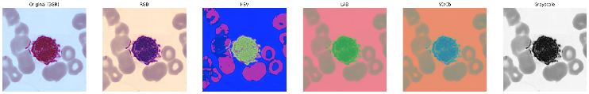
- Color Space Representation & Options

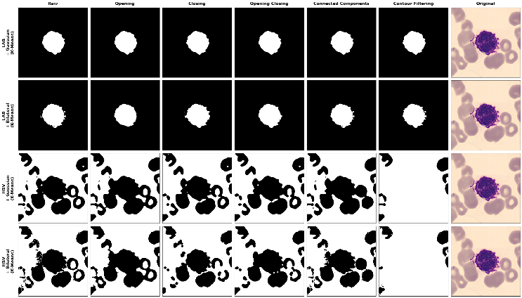
- Morphological Operations vs. (LAB & HSV w/ K-Means Clustering vs. Bilateral & Gaussian Noise Reduction)
This in combination with the fact that CIELAB is used in pharmaceutical and medical sciences [2] affirmed our decision to stick with it for the purposes of segmenting WBCs.

Noise Reduction
Bilateral filtering was selected as the noise reduction technique as it removes artefacts and noise whilst preserving sharp edges at cell boundaries. The OpenCV bilateralFilter() function was applied with parameters d=55, sigmaColor=150, and sigmaSpace=150, determined through systematic trial and error while testing against various thresholding and segmentation techniques. These parameter values were set to maintain border sharpness, especially with cells that required a certain degree of manoeuvrability. Comparison against Gaussian, mean, and median filtering confirmed that bilateral filtering produced the most complete cell borders with the least boundary degradation, refer to Fig. 2. and Fig. 3., notably the first two rows for a clear view behind its effectiveness.
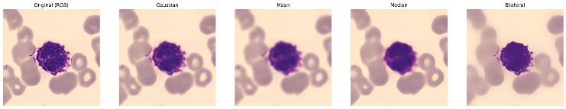
- Noise Reduction Comparison

Thresholding and Segmentation
After noise reduction, the image undergoes segmentation using K-means clustering. Unlike traditional thresholding methods such as Otsu’s, which work best for bimodal images, K-means handles multi-level thresholding by grouping similar pixels into K clusters. This effectively separates foreground objects from the background in images with complex intensity distributions. The algorithm was configured with a stopping criteria of 100 iterations or 70% accuracy threshold, with K=3 clusters, which is the standard practical setting to distinguish between background, cell cytoplasm, and cell nucleus regions. Comparison with Otsu’s method and adaptive thresholding confirmed that K-means produced superior results, particularly when combined with the LAB colour space, as can be seen in Fig. 4 and Fig. 5.
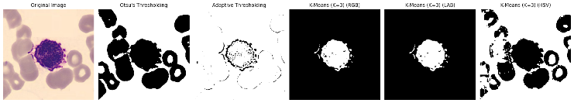
- Thresholding & Segmentation Comparison & Evaluation

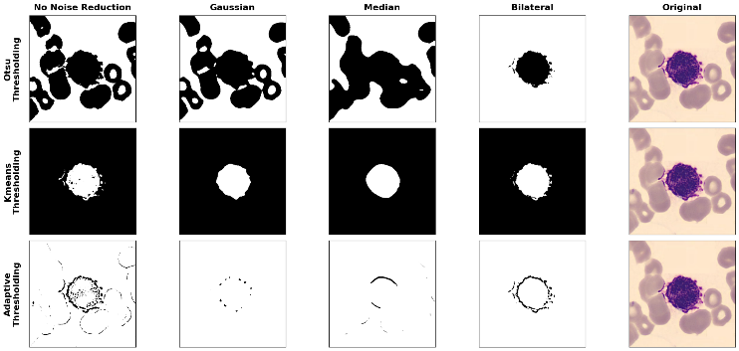
- Thresholding and Segmentation vs. Noise Reduction Techniques

Morphological Operations and Contour Filtering
Following segmentation, binary processing techniques were applied to clean the mask. Several approaches were compared, including morphological opening, closing, opening-closing combinations, connected component labelling, and contour filtering. It ended at a tie between Contour filtering and Closing as they produced the most reliable output when combined with the LAB colour space, bilateral filtering, and K-means segmentation. This method identifies connected regions in the binary mask and retains only the largest contour by area, which typically corresponds to the target cell, in addition to that Contour filtering managed to retain the smaller, partially extended nodules detailed in the prior Figures.

Evaluation Metrics
The segmentation pipeline was evaluated using four standard metrics: IoU, Dice Coefficient, Precision, and Accuracy.
Jaccard’s Index (commonly known as Intersection over Union (IoU)) measures the overlap between predicted and ground-truth masks, it provides a stricter penalty for poor segmentation and is given using:
IoU = $\frac{TP}{TP+FP+FN}$ (1)
The Dice Coefficient (DSC) also measures the overlap between two segmentation masks and is used as a loss function due to its differentiability; it is given using:
DSC = $\frac{2TP}{2TP+FP+FN}$ (2)
The Precision & Accuracy metrics focus on measuring the consistency of results and the closeness to the true value, where precision focuses on minimizing false positives and accuracy was used as a general metric; it is given using:
Precision = $\frac{TP}{TP+FP}$ (3)
Accuracy = $\frac{TP+TN}{TP+FP+FN+TN}$ (4)
In addition to the preliminary metrics conducted during the segmentation section, the usage of the provided “myevalsdk” black-box SDK incorporated more variants of the aforementioned metrics, including:
- Macro & Micro Intersection over Union
- Macro & Micro Dice Coefficient
- Macro & Micro Precision
- Mean Macro IoU, Dice Coefficient & Precision
These metrics were computed across all images in the dataset using the provided “myevalsdk” black-box SDK locally. At the end, the image processing pipeline can be summarized as follows in Fig. 6.:
# 1. Conversion to LAB
lab_image = cv2.cvtColor(img, cv2.COLOR_BGR2LAB)
# 2. Bilateral Noise Reduction
denoised_img = cv2.bilateralFilter(lab_image, 55, 150, 150)
# 3. K-Means Thresholding (k=3)
pixel_values = denoised_img.reshape((-1, 3))
pixel_values = np.float32(pixel_values)
criteria = (cv2.TERM_CRITERIA_EPS + cv2.TERM_CRITERIA_MAX_ITER, 100, 0.7)
_, labels, centers = cv2.kmeans(pixel_values, 3, None, criteria, 10, cv2.KMEANS_RANDOM_CENTERS)
# Stained cell nuclei are the darkest, so we check the Luminance (L) channel (index 0 in LAB)
center_brightness = np.sum(centers, axis=1)
fg_cluster = np.argmin(center_brightness)
labels_flat = labels.flatten()
mask = np.where(labels_flat == fg_cluster, 255, 0).astype(np.uint8)
raw_mask = mask.reshape(img.shape[:2])
# 4. Contour Filtering
contours, _ = cv2.findContours(raw_mask, cv2.RETR_EXTERNAL, cv2.CHAIN_APPROX_SIMPLE)
cleaned_mask = np.zeros_like(raw_mask)
if contours:
for contour in contours:
area = cv2.contourArea(contour)
if area > 1000:
cv2.drawContours(cleaned_mask, [contour], -1, 255, thickness=-1)
- Image Processing Code

Result and Discussion
The proposed image processing pipeline was evaluated both qualitatively on nine selected images (three easy, three medium, and three hard) and quantitatively on the full dataset using the provided SDK, however before we discuss the results it is important to highlight some significant findings.

Dataset Discrepancy
Various critical discrepancies were found in the provided Naturalize dataset, these discrepancies were raised with Dr. Tissa and then relayed to the cohort for transparency’s sake, the first discrepancy refers to dataset count which upon being checked 21,234 files when only 16,117 files should have existed based on the size of the ground-truth folder and this accounted for a surplus of 5117 files, refer to Fig. 8. and 9.
This discrepancy arises because the base dataset contains both .jpg and .png versions for every sequential image (e.g., 01.jpg and 01.png, 02.jpg and 02.png) across multiple subfolders notably; BNE, MY, MMY, PMY, and SNE. To address this, .png files were prioritised over .jpg files for the affected white blood cell subfolders. For subfolders containing only .jpg files, all images were processed as normal. This correction was necessary to ensure that the pipeline evaluated against the correct number of unique images and that the resulting metrics were not inflated or distorted by duplicate processing, a pseudocode algorithm was distributed amongst the class to assist students with implementing their own iterations.
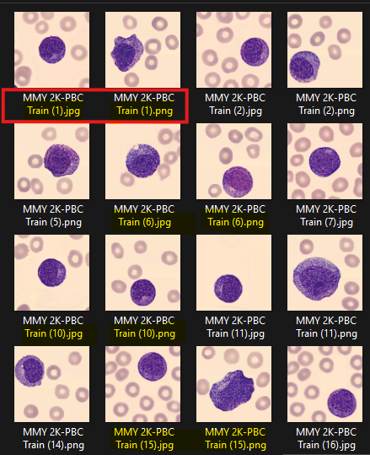
- .jpg & .png Files occupying the same numerical value.
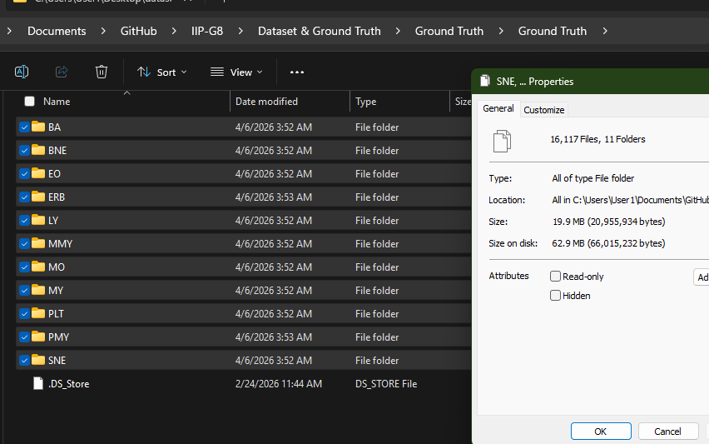
- Ground Truth True Size
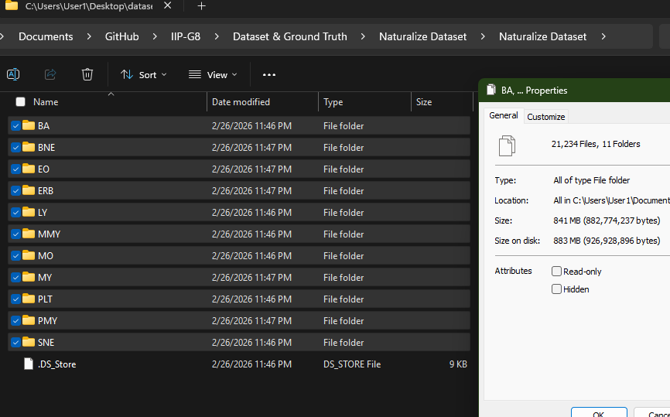
- Naturalize Dataset containing surplus files

Ground Truth Discrepancy
Some of the ground-truth masks were also found to be inaccurate, which may explain a portion of the decreased performance metrics; this was confirmed after communicating with Dr. Tissa and via trial-and-error comparison of ground truths against their corresponding base images.
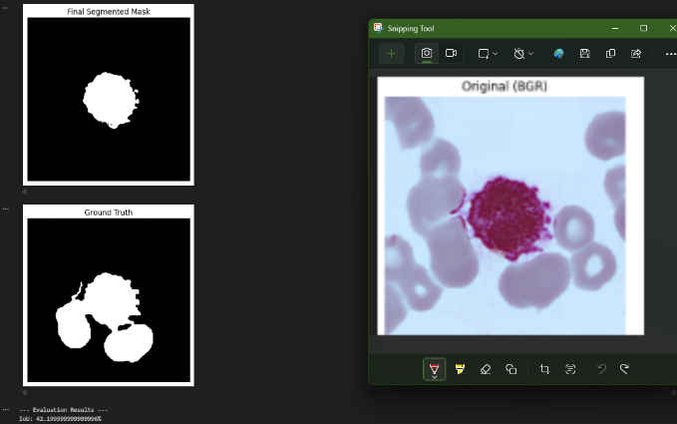
- Ground Truth comparison against Image Pipeline Mask

SDK Utilization & Performance
The SDK’s documentation recommended running it on Google Colab or another cloud-based Jupyter Notebook environment, however after performing comprehensive testing on local machines with varying degrees of compute it was determined that running the SDK locally would significantly cut down on classification and evaluation time, as running the SDK on Google Colab with CPU would process the images at a rate of 7s/it while most local machines provided faster evaluation rates at 0.8-2.0 it/s.
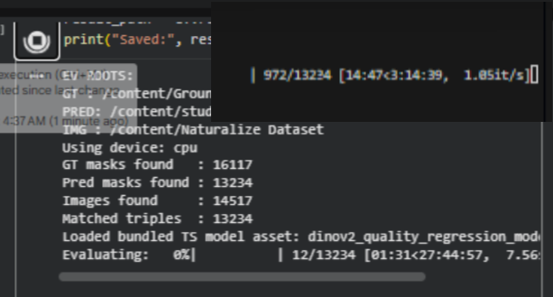
- Google Colab vs. Local Machine Processing Speed

Qualitative Analysis
For the easy samples, the pipeline produced visually strong results. The segmented objects were large, well-preserved, and clearly separated from the background, with overall cell shapes retained effectively, they can be accessed in the Results 2026 IIP – Group008 Folder. The medium and hard samples remained acceptable, though cell borders became less smooth and some fragmentation appeared around outer edges as seen in Fig. 12 with a 93.53% IoU and 96.66% DSC. It is of note that for all samples, unique and hard images were selected to actively test the model’s capacity with the following comments present for each sample grouped from easy to hard:
# Chosen due to its large size and assymetric shape.
# Chosen due to the lighter shade
# Chosen due to its different, slightly more pinker color and lighting.

# Chosen to check the effect of different colored regions.
# Chosen as we were able to detect the external smaller cell compared to the ground truth.
# Chosen to act as a baseline test

# Chosen as the ground truth is inaccurate and it beats it by highlighting the center nuclei.
# Chosen as it matches the ground truth but I'm personally uncertain on whether the outer shades should be included or not
see how the pipeline works with varying borders (reasonably well but it missed the teeny center left bit)
- PMY/MMY 2K-PBC Train (15) Analysis

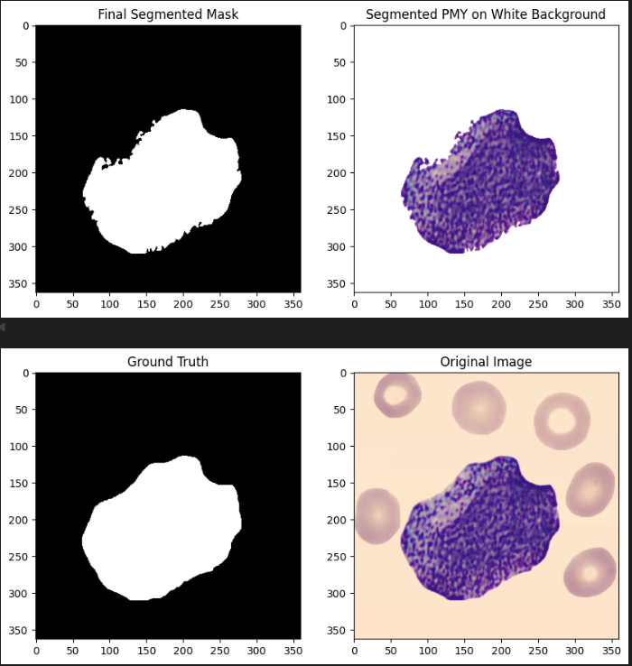
- PMY/MMY 2K-PBC Train (15) Analysis

Overall, the qualitative results show that the proposed pipeline is capable of generating visually coherent segmentations and tend to hold up pretty well as image difficulty increases with a slight issue arising with edge erosion. This will end up becoming more prevalent when reviewing the quantitative results later.

Quantitative Results
The full semantic evaluation was performed on 16,117 images, with inference successfully completed for all samples after implementing the priority algorithm. This confirms the pipeline was fully automatic and stable across the complete dataset. The quantitative metrics achieved are listed in Table 1.
- First Run Results
Table Column Head
Metric | Score
Macro & Micro IoU | 0.679358 & 0.661506
Macro & Micro Dice Coefficient | 0.752950 & 0.796273
Macro & Micro Precision | 0.860579 & 0.928866
Model Macro mIoU | 0.623953
Model Macro mean Dice | 0.629104
Model Macro mean Precision | 0.617875
These results have proven to be sub-par given our qualitative results averaging in the high 80’s and 90’s, however this can be attributed to various factors which will be discussed, however before doing so it should be noted that due to the focus on modularity and ease of orchestration when creating the test suite, we were capable of performing quick tests against other variables, including modifying the colour space and morphological operation to LUV & Closing which allowed us to produce these results.
These results have proven to be sub-par given our qualitative results averaging in the high 80’s and 90’s, however this can be attributed to various factors which will be discussed, however before doing so it should be noted that due to the focus on modularity and ease of orchestration when creating the test suite, we were capable of performing quick tests against other variables, including modifying the colour space and morphological operation to LUV & Closing which allowed us to produce these results.
- First Run Results
Table Column Head
Metric | Score
Macro & Micro IoU | 0.692331 & 0.678438
Macro & Micro Dice Coefficient | 0.761432 & 0.808416
Macro & Micro Precision | 0.860579 & 0.928866
Model Macro mIoU | 0.727467
Model Macro mean Dice | 0.731011
Model Macro mean Precision | 0.723810
Chasing these two modes provided us with a minimum increase of 10% across all model macro mean metrics and is valuable to note for future research.

Critical Evaluation
The pipeline’s key strength is its high precision. The micro Precision of 0.929 indicates that when the model predicts a pixel as foreground, it is overwhelmingly correct, meaning the output masks are generally clean and focused. The Dice scores are also reasonably strong (micro Dice of 0.796), indicating good overlap between predicted and ground-truth masks. Considering the method relies on traditional image processing rather than deep learning, this is a positive result demonstrating that a well-designed classical approach can still perform effectively.
However, the lower IoU values (micro IoU of 0.662) indicate that whilst the pipeline identifies the correct region, it does not always capture exact boundaries. The gap between Precision and IoU suggests the pipeline is somewhat conservative, favouring the most confident foreground pixels whilst avoiding uncertain areas. This reduces false positives but leads to under-segmentation. The higher micro scores compared to macro scores suggest the pipeline performs better on more common or easier cases, with less consistency across challenging images.
A notable limitation is the pipeline’s dependence on strong visual contrast between foreground and background. When the cell is well differentiated, performance is strong; when contrast is weaker or the outer cytoplasmic region is pale, performance degrades. The reliance on fixed parameters (e.g., the assumption that the darkest K-means cluster corresponds to the foreground) means the method cannot adapt to variations in lighting, contrast, or cell morphology across the dataset.

Conclusion
This paper presents a modular WBC segmentation pipeline evaluated on the Naturalize dataset, this was achieved by combining CIELAB colour space conversion, bilateral filtering, K-means clustering, and contour filtering. The pipeline achieve a Macro and Micro Precision of 0.861 & 0.929, demonstrating that the predicted foreground pixels are highly reliable while our Macro IoU of 0.679 indicates that the boundary-level accuracy remains a limitation, notably for cells with lower contrast against the background or irregular RBCs.
Furthermore, manual data analysis revealted that dataset integrity issues, including duplicate .jpg/.png file pairs inflating the total count to 21,234 files in addition to inaccurate ground-truth masks, may partially account for a decreased quantitative score. These discrepancies were formally raised and represent an important consideration for future work.

References

- M. Abou Ali, F. Dornaika, and I. Arganda-Carreras, ‘Blood Cell Revolution: Unveiling 11 Distinct Types with “Naturalize” Augmentation’, Algorithms, vol. 16, no. 12, 2023.
- Marefat S, Shayanfar A, Monajjemzadeh F. “Developments in image-based colorimetric analysis methods and applications of CIElab color space in pharmaceutical sciences: A narrative review.”, Int J Pharm X. 2025 Nov 1;10:100434. doi: 10.1016/j.ijpx.2025.100434. PMID: 41280507; PMCID: PMC12634856.

